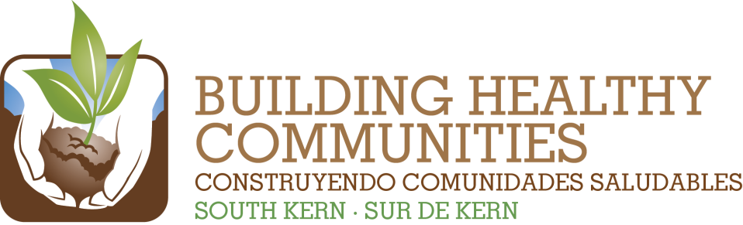
We

Bu |  |  | In This Issue

Action Team Report – Education
Month: Submitted by:
Brief Summary of the Action Team Meeting and Work (200 words or fewer)
Include any highlights/accomplishments, or challenges.

Findings or needs related to Communications or Evaluation/Learning

2014 Result | Summary of Work and Progress  Include number new/total and details about progress of work
Fifteen South Kern parents are continuing and expanding their role as leaders and advocates for student health by participating in District Wellness Committees.
Thirty South Kern parents are actively engaged in creating a school culture of meaningful parent involvement and leadership and school funding policies that support success for all students
Twenty South Kern parents, in partnership with school districts, are creating safer and more supportive school environments through individual advocacy and broad-level engagement.
Ten schools in South Kern have established alternative positive discipline models in partnership with parents.
Through a partnership with local colleges and high schools, student pathways to higher education will be strengthened and South Kern youth participation in college will increase by 20%.
Please attach a copy of the meeting sign-in sheet.

