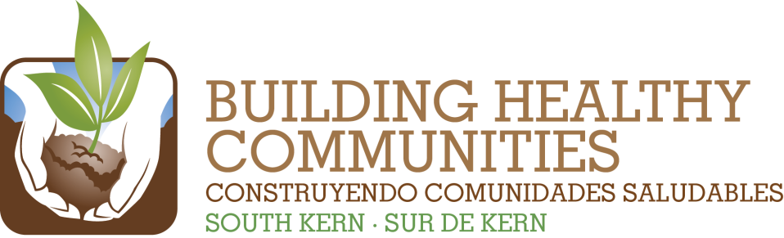
We

Bu |  |  | In This Issue

Action Team Report – Health
Month: May 22, 2014 Submitted by: Bill Phelps, Co-chair
Brief Summary of the Action Team Meeting and Work (200 words or fewer)
Include any highlights/accomplishments, or challenges.
Bill will send out a Doddle to set up a planning meeting for the Emergency Department Access
Forum. The primary discussion at our meeting was around what we need to be doing post
outreach and enrollment. CHI has created a Client Utilization Survey and database system that
they will demonstrate on 6/4/14 from 10-11 am at 1919 16th St. We also discussed the future
of the CEC program and issues around DACA and PRUCOL Medi-Cal denials for DHS. We
concluded our discussion by making plans to present at the next BHC Steering Committee.
Findings or needs related to Communications or Evaluation/Learning
We will need some assistance in planning a community forum for this fall.

2014 Result | Summary of Work and Progress  Include number new/total and details about progress of work
Continue partnering with residents and community partners to increase the number of South Kern residents newly enrolled in health insurance by 1,500. | Nearly 4,000 Medi-Cal and Covered California applications were submitted by partner agencies between 10/1/13 and 3/31/14. We have far exceeded the goal of 1,500 newly enrolled residents.
Establish family-centered care practices in three local clinics. | CSV continues to pursue Patient Centered Medical Home accreditation through the Joint Commission and the National Center on Quality Assurance over the next several years.
Increase the availability and integration of health services through non-traditional venues including: schools; mobile clinics; and non-traditional providers and supports such as interns. | Debbie W. shared several examples on how the role of school nurses is expanding to provide more health care services in school settings for managing students’ chronic illnesses. She also mentioned the annual eye care services that are provide to schools county wide. Bill P. mentioned that one of CSV’s refurbished mobile medical/dental units is back in Kern County. The other is due back in the next month.
Create a culture of prevention among 100% of BHC-SK community partners by integrating education on appropriate emergency/urgent care usage as a standard practice during enrollment and linkage services. | We continued discussing how we would implement an education plan during the next open enrollment period. Dignity is working on a flyer or brochure on appropriate utilization of ER/Urgent care visits with an emphasis on preventative care. GBLA also has resource material to share.
Advocate for local government leaders to hold a community forum on emergency health care needs and resources in South Kern. | The Health Action Team is moving forward on creating a community forum around emergency services in partnership with Supervisor Perez’s office sometime in the fall of 2014.
Please attach a copy of the meeting sign-in sheet.

