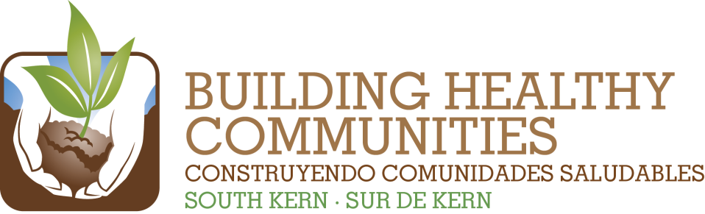
We

Bu |  |  | In This Issue

Action Team Report – Recreation
Month: April 2014 Submitted by: Amerika Nino-Rodriguez
Brief Summary of the Action Team Meeting and Work (200 words or fewer)
Include any highlights/accomplishments, or challenges.
Amerika announced her last with BHC will be 4/26. Jose Pinto talked about mini grants for materials, not for services and announced that the deadline is May 5th. Many of our partners are planning to apply. Bob will follow up with Jorge regarding Rexland Mural work. Javier mentioned that he has a contact with an organization that works on murals with a one day workshop model. It was recommended that we work with the Arvin High School Audio Visual class/group for future video projects. Bear Mountain announced that two of the trees planted were vandalized. Greenfield Sports Association announced registration for summer sports (football, cheer, tball) and referee training (youth 14-up). Team discussed May 8th presentation to Steering Committee and most plan to attend.
Findings or needs related to Communications or Evaluation/Learning
Team found that it is very beneficial when Hub staff attends our monthly meetings for feedback, direction and to answer team questions. Hub is a valuable part of our team.
2014 Result | Summary of Work and Progress  Include number new/total and details about progress of work
Increase awareness of and coordination among local recreation programs through completion, promotion and institutionalization of a catalog of recreation opportunities. | No update
Increase long-term sustainability of recreation opportunities through identification of potential revenue or funding models for South Kern recreation. | Amerika spoke with TCE (Annalisa Robles) regarding identifying an organization(s) to help us move this work forward. Team commits to having action steps to follow TA. Team requests TA to provide us with their expertise, gather community input and provide recommendations to us.
Support residents, including youth, in partnering with local recreation systems and advocating for continued improvements to local parks through implementation of park master plans and/or skate parks in four local parks. | Master Plan draft review for DiGiorgio and Weedpatch scheduled for April 30th from 4p-6p at Caliente Creek Apartments in Arvin (909 Meyer).  Kaboom work for Lamont Park: Grant from Kaboom is for $15,000 but we need a total $50,000. We are in the stages of local fundraising and are at about 20,000 right now. The goal is to raise $40,000 locally with a build day in June. Supervisors office sought Kaboom grant because the need was identified in the master plan. Will likely need 100 volunteers for build day.
Continue to support residents and community partners in increasing awareness of and advocating for policies that make local parks safer and cleaner. | Bob will have numbers for next report (contacts, warnings, citations at all parks).
Please attach a copy of the meeting sign-in sheet.

