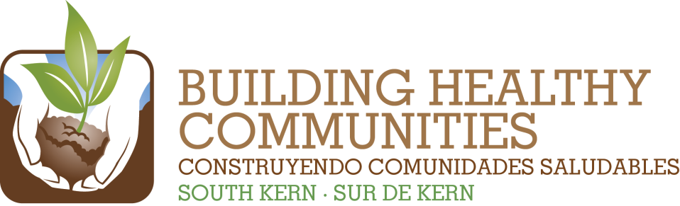
We

Bu |  |  | In This Issue

Action Team Report – Environment
Month: January 2015 Submitted by: Cesar/Veronica
Brief Summary of the Action Team Meeting and Work (200 words or fewer)
Include any highlights/accomplishments, or challenges.
Arvin Market Corner Store Conversion: Kern County Environmental Health worked with store owner as part of a project to install two refrigeration units for fresh produce, clean up, new paint job and take down of unhealthy marketing. After project completion sales went up from $60-70/week to $200-250/week and owner expects increase in summer. Produce delivery is 1 time/weeks and by the summer he’ll need about 2-3 times/week. WIC and EBT sales have increased for not only produce but for dairy, eggs and cheese. One refrigeration unit was for produce and the second refrigeration unit for milk, cheese and eggs.
Findings or needs related to Communications or Evaluation/Learning

2014 Result | Summary of Work and Progress  Include number new/total and details about progress of work
Support twenty South Kern residents in monitoring local environment conditions and reporting on environmental hazards, (e.g., KEEN, Bucket Brigade). | The first KEEN meeting this year took place on 1/6/2015. This month we were able to close a couple of reports of the agenda. Furthermore, this month a notice of violation was filed against Petro Capital Resources through KEEN for a violation of excess VOC’s being released from waste gas storage tanks. This notice of violation is significant because to get evidence for this report KEEN and other partners worked to gather low-cost monitoring data (used an infrared camera) that prompted a reaction from the Air District. In the last couple of months we worked to establish a much better working relationship with the Air District and this is a violation that begins to showcase that trust being built as they trusted the data we collected. In the coming months we will be beginning the process to create measurement standards for the network.
Support twenty South Kern residents and partners in advocating for improved policies and enforcement at the county, regional and state level that will create a healthy environment. | Leadership Counsel has talked to County about the upcoming General Plan and Housing Element update, as well as SB 244 compliance. These decision making processes will create opportunities to adopt policies and programs that will improve overall environment. CCEJN, CRLA and Leadership Counsel will be involved in this processes. This time around CRLA and CCEJN are researching ways of challenging the concentration of dairies in areas around Lamont and other processes.
Advocate at the local, county and state level for funding and implementation of at least 3 major water/sewer infrastructure improvements in South Kern. | Due to a historic water bond and groundwater legislation advocated by many community members -- 10% of the funds have been earmarked to serve disadvantaged communities. This can be used to fund technical assistance, operations & management, and sewer systems in communities. Another great thing about this funding is that private wells and small water systems will be able to access the funding were as previously they weren’t able to. CWC, Leadership Counsel will be engaged in guideline development that will drive funding decisions.
Support residents and community partners in advocating for and implementing immediate drinking water solutions in at least 25 community settings such as schools or parks. | Agua4All camping in South Kern was launched with great success in Lamont on January 29th. Lamont is getting bottled filling stations in the next couple of months.  Point of use filters in Arvin have been approved by the State Water Board  Interim safe drinking water in Arvin, for 3 years as we move forward for the long term solution in Arvin.  CWC and CCEJN also received funding through the Regional Water Board Supplemental Environmental Projects pilot round in 2014. Central Valley SEPs are significant because this is the first time that SEP’s are done in this way. In the coming months more discussions will follow about making other governmental agencies follow similar procedures to allow violation money to fund community projects. This time CWC gained support for a private well testing program – a community monitoring program that samples for depth of private wells over time, and water quality. CCEJN received support to form water monitoring networks in Lamont and Arvin as water quality protection monitors. CCEJN and CWC will work to see if it is possible to collaborate on the monitoring projects and use KEEN as a platform for information gathering and system of analysis.
Support residents and decision-makers in local communities in implementing health-promoting land-use policies that have been created, (e.g., general and regional land-use plans). | At the State level--Cap & Trade dollars will be distributed in the next 3-4 months. Leadership Counsel participated in the state hearing where guidelines were adopted to support housing, infrastructure and transportation related projects to elevate importance of investing in lower income rural communities. CCEJN and CRLA are also following this process as guidelines make it difficult to push projects for small scale communities. Leadership Counsel has met with Kern County and Kern COG to discuss project opportunities.  Leadership Counsel has met with Kern COG staff to also discuss ATP funds and opportunities under their TA grant assistance program. Staff is willing to work with communities to put projects forward. Their application to prepare a regional Active Transportation Plan was not awarded. They would like to re apply this year. They will send the application to us for our review and have asked for our support.
Please attach a copy of the meeting sign-in sheet.

