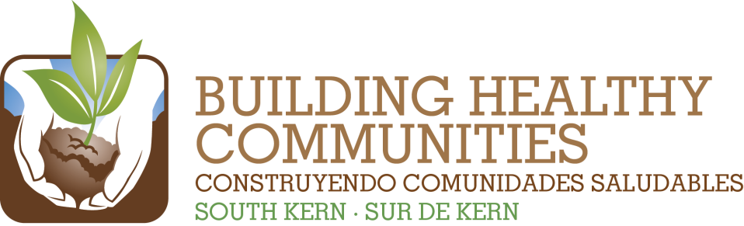
We

Bu |  |  | In This Issue

Action Team Report – Health
Month: October 22, 2015 Submitted by: Bill Phelps, Co-chair
Brief Summary of the Action Team Meeting and Work (200 words or fewer)
Include any highlights/accomplishments, or challenges.
The Health Action Team met on October 22, 2015. The primary purpose of the meeting was to reviewd the promises we would be presenting at the Community Celebration on November 7, 2015. Lisa Elliott from Transforming Local Communities and Jennifer Wood, HUB Manager, led the discussion. The draft document was mailed out for additional comments and feedback.

We also had updates on the following activities:

- Health4All: This group is meeting monthly to develop strategies to develop a county-level solution for some type of health care program for undocumented adult residents. Undocumented children will be covered starting in May 2016. We discussed the importance of getting these children enrolled now into Emergency Medi-Cal so that they will roll directly over into full-scope Medi-Cal once the expanded coverage is made available to this population. The next meeting was scheduled for 10/28/15 from 12 to 2 pm at the Greenfield FRC.

- Open Enrollment: Dignity Health’s Community Health Initiative was planning to host a press conference on 10/30/15 to kickoff the next open enrollment period for Covered California which will run from 11/1/5 to 1/31/16. All interested agencies were encouraged to attend. Dignity, Greenfield FRC and Clinica provided updates on their outreach and enrollment plans.

- All Action Team Meeting will be held on 11/19/15 from 3 to 5 pm

- Facilitator Training will be held on 12/4/15 from 8:30 am to 3:30 pm at the Greenfield Union School District office.

Our next meeting will be held a week early due to the Christmas holiday. We will be meeting on December 17, 2015 from 3:30 to 5:00 pm at the Greenfield Union School District office.

Review Action Plan Progress
2014/2015 Result | Summary of Work and Progress  Include number new/total and details about progress of work
Continue partnering with residents and community partners to increase the number of South Kern residents newly enrolled in health insurance by 1,500. | Over 5,000 Medi-Cal and Covered California applications were submitted by partner agencies between 10/1/14 and 4/30/15. We have far exceeded the goal of 1,500 newly enrolled residents. See attached report for details on Kern CEE applications.
Establish family-centered care practices in three local clinics. | CSV continues to pursue Patient Centered Medical Home accreditation through the National Center on Quality Assurance over the next several years. CSV received certification by the Joint Commission as a Primary Care Medical Home on April 18, 2014. There are still a number of steps to complete before this model is fully implemented.
Increase the availability and integration of health services through non-traditional venues including: schools; mobile clinics; and non-traditional providers and supports such as interns. | Debbie W. shared several examples on how the role of school nurses is expanding to provide more health care services in school settings for managing students’ chronic illnesses. She also mentioned the annual eye care services that are provide to schools county wide. CSV has refurbished both mobile medical/dental units and waiting on final licensure approval.
Create a culture of prevention among 100% of BHC-SK community partners by integrating education on appropriate emergency/urgent care usage as a standard practice during enrollment and linkage services. | The Outreach, Enrollment, Retention and Utilization Committee (OERUC), through the Community Health Initiative, have finalizing the revisions to the health care access handbook to address the utilization of emergency/urgent care usage along with many other health tips and useful information. The revised booklet is now available for enrollment counselors to use.
Advocate for local government leaders to hold a community forum on emergency health care needs and resources in South Kern. | Accessing Emergency Services Forum was held on October 16, 2014.
Please attach a copy of the meeting sign-in sheets.

